



**Industry Project 3A**

**CSE3PRA**

**Lecturer: Mrs. Elle Chan**

**Coordinator: Dr. Torab Torabi**

**Team NSW-Enterprise**

**Student name: Xiaopeng Li (18386537)**

**Student name: Ruolin Xie()**

**Student name: Tai Yone Min()**

**Student name: Yue Yin()**

**Key point**

1. **Introduction**
2. **Software Design Scope**
3. **Reference Documents**
4. **User stories**
5. **Object-Oriented Design**
6. **Software Release Report**
7. **Additional User Interface Design**
8. **Special Notes**

**Table of Contents:**

1. **System Maintenance Document ………………………………………………………… 3**
   1. **Table of Contents …………………………………………………………………………… 3**
   2. **1.0 Introduction ……………………………………………………………………………… 3**

**1.2.1 System Overview ……………………………………………………………………… 3**

**1.2.2Audience Description………………………………………………………………. 3**

**1.2.3 Applicability Statement………………………………………………………….... 3**

**1.2.4 Purpose Statement ……………………………………………………………….…. 3**

**1.2.5Document Usage Description…………………………………………………… 6**

1. **Introduction …………………………………………………………………………… 6**
2. **Software Design Scope …………………………………………………………… 6**
3. **Reference Documents …………………………………………………………… 6**
4. **User Stories ………………………………………………………………………. 6, 7**
5. **Object-Oriented Design ………………………………………………………… 7**
6. **Software Release report ………………………………………………………… 7**
7. **Additional User Interface Design …………………………………………… 7**
8. **Special Notes …………………………………………………………………………. 7**

**1.2.6 Conventions …………………………………………………………………………. 7**

**1.2.7 Change Log …………………………………………………………………………… 7**

**1.3 2.0** **Software Design Scope …………………………………………………………… 9**

**1.3.1 Major Software Functions …………………………………………………9, 10**

**1.3.2 Major Design Constraints and other Requirements …………… 10**

**1.4 3.0 Reference Documents ……………………………………………………… 10**

**1.4.1 Existing Software Documentation ………………………………… 11**

**1.4.2 System Documentation ………………………………………………… 11**

**1.4.3 Vendor Documentation …………………………………………………. 11**

**1.4.4 Other Documentation …………………………………………………… 11**

**1.5 4.0 User Stories …………………………………………………………………… 11**

**1.5.1 Android Unit Testing …………………………………………11, 12, 13**

**1.5.2 User Story Dictionary………………………………………………13, 14**

**1.5.3 As an Administrator I want to register………………………14, 15**

**1.5.4 As an administrator I want to Log in……………………………15, 16**

**1.5.5 As an Administrator I want to Log out…………………………… 17**

**1.5.6 As an Administrator I want to retrieve password when I do not remember login details………………………………………………………… 17, 18, 19**

**1.5.7 As an Administrator I want to book visiting time on the website…………………………………………………………………………………………19, 20, 21**

**1.5.8 As an Administrator I want to cancel the booking time on the website……………………………………………………………………………………………21, 22, 23**

**1.5.9 As a Website Provider I want to register…………………23, 24, 25**

**1.5.10 As a Website Provider I want to Log in………………………25, 26**

**1.5.11 As a Website Provider I want to Log out……………………26, 27**

**1.5.12 As a Website Provider I want to retrieve password when I do not remember login details……………………………………………………………27, 28, 29**

**1.5.13 As a Website Provider I want to know the booking details when it is a group booking request…………………………………………………29, 30, 31**

**1.6 5.0 Object-Oriented Design………………………………………………………31**

**1.6.1 High Level System Architecture ……………………........31, 32, 33**

**1.6.2 Use Case Diagram.............................................................33**

**1.6.3 Modular GUI.....................................................................34**

**1.6.4 Object Dictionary.............................35,36,37,38,39,40,41,42**

**1.7 6.0 Software Release Report…………………………………………………… 42**

**1.8 7.0 Additional User Interface Design…………………………………….… 42**

**1.9 8.0 Special Notes………………………………………………………………...42,43**

1. **Introduction:**

**1.2.1 System Overview**

A Nursing Home / Aged Care Visitor Management is a web-based software is required that will efficiently work the way your organisation manages visitors, contractors and staff on a single site or on multiple sites across the country and around the world. It is oriented to help organisation to manage visitors, contractors and staff through one or multiple websites.

A booking management system is utilised for visitors to sign up with their personal information and allocate reservation online. Staff and contractor are able to log in to view their allocation of work or employee detail on the website.

This system will work on any applications which contains a browser and is made to reduce of having a receptionist and created convenience for staff and contractors.

Such a setup will create an easy to use tool for visitors and contractors to notify the person they are here to see of their arrival.

This takes away the need of having a receptionist and so notifying a staff member of your arrival was impossible and created a lot of frustration for our staff and for the visitors.

Visitor Management will help the staff and visitors and take away the pressure on them and allow them to focus on their own work instead of continually moving to help visitors.

**1.2.2Audience Description**

The audience of this project is primarily visitor of aged care residents, employees and general contractors aimed to increase reception productivity.

* Visitors are required to sign up with their personal information and relationship with the resident and it is distinguished between individual and group (e.g. group of volunteers are performing a show during Christmas).
* Staff and constructor are offered services oriented to provide information of Nursing home and work tasks. To be a user of this application users must have:

-Created account on the web portal

-An available registered service -Details of the service provided (location, phone number, employee or constructor id...etc).

**1.2.3 Applicability Statement**

**Software**

Any application that web browser service can be installed on the application

**1.2.4 Purpose Statement**

The purpose of Nursing Home /Aged Care Visitor Management is to:

* Provide the visitors with tools for making a reservation online
* Provide the visitors with adequate information about the Nursing Management Service and Onshoring Company
* Provide the visitor with satisfying information regarding services or preferences
* Provide the visitors, staff and contractors with communication channels regarding services or preference via online
* Allow the staffs to be reached by visitors/residents through the website
* Allow the staffs to make their services available to users of the website
* Allow the staff to log into account to
* Enhance reception productivity
* Improve visitors’ safety
* Create online induction
* Service Provider Portal to easily manage contractor and supplier profiles and compliance
* No software to download
* Easy and quick Deployment

**1.2.5 Document Usage Description**

1. Introduction

This Section of the document provides information regarding the purposes of the app application and its functionalities. Covering the targeted market of the application, this section contains an explanation of the system, conventions used and components together with the environments in which the developing process of the application took place.

2.0 Software Design Scope

This section contains information regarding the major software functions and its capabilities. Covering the benefits this software provides to visitors, staffs and contractors and it is made to improve aged care sector’s reception productivity while secure residents’ personal information.

3.0 Reference Documents

This section contains the support documents regarding the system design and software used. Including a description of the project itself, this section covers all the referencing of third-party software and other tools used on the developing of the application.

4.0 User Stories

This Section contains the user stories regarding the application along with the definition for each user story and its behaviour showing how the functionality of the app is implemented, the benefits provided to the user and the size of this task regarding the amount of work it required to be completed. Supporting each user Story, in this section can be found: the user story definition explaining the user story a flow of interaction diagram to follow the steps the user story goes through wireframes for each user story describing the steps to go through a user story. The user story testing which describes the tests carried out for each user story in order to accomplish the acceptance criteria.

5.0 Object-Oriented Design

This section contains all the system design documents explaining behaviour, relations among the system, components and architecture of the system. In addition, this section contains an object dictionary all the objects developed for the system, system designers and maintainers.

6.0 Software release report

This section contains all the processes and activities regarding the deployment of the system covering the usability tests of the system and a report that guaranties the implementation of the user stories and their perfect functionality.

7.0 Additional User Interface Design

In this section screens of the input, output and communication of data between the system and the user are provided.

1. Special Notes

Relevant information, descriptions or procedures that are not included elsewhere in the documents.

**1.2.6 Conventions**

The conventions shared among the different components of the system are:

Code Languages： The usage of tools as HTML5 and Phalcon php UML conventions(diagrams) Formats regarding: user stories, tests and integration testing Name Conventions on the website regarding the communication with the API

**1.2.7 Change Log**

|  |  |  |
| --- | --- | --- |
| **Date** | **Change** | **Person Responsible for the change** |
| May 23, 2019 | Creation of the Table of Contents | * Created by Tai Yone Min |
| May 23, 2019 | Table of Figures | * Created by Tai Yone Min |
| May 23, 2019 | 1.0 Introduction | * Created by Tai Yone Min |
| May 23, 2019 | 1.2.7 Change Log | * Created by Tai Yone Min |
| May 23, 2019 | 2.0 Software Design scope | * Created by Tai Yone Min |
| May 23, 2019 | 1.3.1 Major Software Functions | * Created by Tai Yone Min |
| May 23, 2019 | 1.3.2 Major Design Constraints and other Requirements | * Created by Tai Yone Min |
| May 23, 2019 | 1.4 3.0 Reference Documents | * Created by Tai Yone Min |
| May 23, 2019 | 3.2 System Documentation | * Created by Tai Yone Min |
| May 23, 2019 | 3.3 Vendor Documentation | * Created by Yue Yin |
| June 1, 2019 | 1.5 4.0 User Stories | * Created by Yue Yin |
| June 1, 2019 | 1.5.2 User Story Dictionary | * Created by Yue Yin |
| May 24, 2019 | 1.5.3 As an Administrator I want to register | * Created by Ruo Lin |
| May 24, 2019 | 1.5.3 As an Administrator I want to register | * Created by Ruo Lin |
| June 1, 2019 | 8.0 Special Notes | * Created by Xiaopeng Li |
| May 25, 2019 | 1.1 Table of Contents | * Updated by Xiaopeng Li |
| May 25, 2019 | 1.2.6 Conventions | * Created by Xiaopeng Li |
| May 25, 2019 | 8.0 Special Notes | * Created by Xiaopeng Li |
| May 25, 2019 | 1.2.7 Change Log | * Updated by Xiaopeng Li |
| May 26, 2019 | 1.2.7 Change Log | * Updated by Ruo Lin |
| May 26, 2019 | 1.2.7 Change Log | Updated by Yue Yin |
| May 27, 2019 | 1.3.1 Major Software Functions | * Updated by Ruo Lin |
| May 27, 2019 | 1.3.2 Major Design Constraints and other Requirements | * Updated by Ruo Lin |
| May 27, 2019 | 1.4 3.0 Reference Documents | * Updated by Ruo Lin |
| May 27, 2019 | 1.5.12 As a Website Provider I want to retrieve password when I do not remember login details | * Created by Ruo Lin |
| May 27, 2019 | 1.6.2 Use Case Diagram | * Created by Yue Yin |
| May 27,2019 | 1.6.3 Modular GUI | * Created by Yue Yin |
| May 28,2019 | 1.6.4 Object Dictionary | * Created by Tai Yone Min |
| May 28, 2019 | 1.9 8.0 Special Notes | * Updated by Yue Yin |
| May 29, 2019 | 6.0 Software Release Report | * Created by Xiaopeng Li |
| May 29, 2019 | 7.0 Additional User Interface Design | * Created by Xiaopeng Li |

**1.3 2.0Software Design Scope**

**1.3.1 Major Software Functions**

Major software functions of the Nursing Home /Aged Care Visitor Management system are

* Reservation Management

Add reservation

Select reservation time and date

Receive reservation confirmation

* Log Management

Log activities

Verification of accounts

Report issue

* Database management

Store residents details

Store visitor details

Create a search bar for general information retrieval

* Service Management

Respond visiting request

Confirm reservations

Update resident details

* Social Networking

Review/Rate

Sharing via social platform

* Information Management

Indicates aged care centre information

Indicates contact details and visiting hours

Insert image of visitor centre

**1.3.2 Major Design Constraints and other Requirements**

The following list contains the constrains in the design and development of the system

* The system must run in crossed platform
* Maintain consistency of the website
* Verify account with accurate personal information for security purpose
* The website should be user friendly and easy to navigate through
* Database consistency with mobile APP browser
* Get reservation detail immediately and respond quickly through website
* Maintain high consistency and reliability for the system
* Clearly indicate personal information of each type of users

**1.4 3.0 Reference Documents**

**1.4.1 Existing Software Documentation**

Any existing documents related to the software being designed will be listed here:

Project Description: insert PDF file

First client meeting notes: insert PDF file

**1.4.2 System Documentation**

* The software is not being developed from an embedded existing system.

**1.4.3 Vendor Documentation**

Third-party software:

**Wordpress:** Wordpress gives you everything you need to start your website. It provides free hosting, your own domain, a world-class support team and so much more.

Worldpress WebPage: <https://wordpress.com/create/?currency=AUD&sgmt=gb&utm_source=google&utm_campaign=Google_WPcom_Search_Brand_Desktop_AU_en&utm_medium=paid_search&keyword=wordpress&creative=329692019903&campaignid=647897985&adgroupid=57942200368&matchtype=e&device=c&network=g&cpn=647897985&device=c&pl=&targetid=kwd-313411415&locationid=9071791&gclid=EAIaIQobChMIierVg-Kw4gIVBRqPCh3JYwrfEAAYASAAEgIOwPD_BwE&gclsrc=aw.ds>

**Phpmyadmin:** Phpmyadmin is a free software tool written in PHP, intended to handle the administration of MySQL over the Web. Phpmyadmin supports a wide range of operations on MySQL and MariaDB.

Phpmyadmin WebPage: <https://www.phpmyadmin.net/>

**1.4.4 Other Documentation**

**1.5 4.0 User Stories:**

**1.5.1 Android Unit Testing**

**TC1-1: MainActivity.java**

|  |  |  |  |  |  |  |
| --- | --- | --- | --- | --- | --- | --- |
| **Test Case ID** | **Test Objective** | **Test Input** | **Actual Input** | **Expected result** | **Actual Result** | **Status** |
| TC1-1-1 | Validate activity is not null | N/A | Open the browser and check whether all buttons are loaded | Content View is set to activity_main.xml | As expected | Pass |
| TC1-1-2 | Validate launch of another activity | N/A | Click on Log In | LogInActivity.class is loaded | As expected | Pass |

**TC1-2: LogInActivity.java**

|  |  |  |  |  |  |  |
| --- | --- | --- | --- | --- | --- | --- |
| **Test Case ID** | **Test Objective** | **Test Input** | **Actual Input** | **Expected result** | **Actual Result** | **Status** |
| TC1-2-1 | Validate activity is not null | N/A | Observe on LogInActivity.class is loaded | Content View is set to activity_ LogInActivity.xml | As expected | Pass |
| TC1-2-2 | Validate launch of another activity LogInButtonOnClick() | N/A | Click on Log In with default setting | LogInActivity.class is loaded | As expected | Pass |

**TC1-2: MainActivity.java**

|  |  |  |  |  |  |  |
| --- | --- | --- | --- | --- | --- | --- |
| **Test Case ID** | **Test Objective** | **Test Input** | **Actual Input** | **Expected result** | **Actual Result** | **Status** |
|  |  |  |  |  |  |  |
|  |  |  |  |  |  |  |

**TC1-3: MainActivity.java**

|  |  |  |  |  |  |  |
| --- | --- | --- | --- | --- | --- | --- |
| **Test Case ID** | **Test Objective** | **Test Input** | **Actual Input** | **Expected result** | **Actual Result** | **Status** |
|  |  |  |  |  |  |  |
|  |  |  |  |  |  |  |

**TC1-4: MainActivity.java**

|  |  |  |  |  |  |  |
| --- | --- | --- | --- | --- | --- | --- |
| **Test Case ID** | **Test Objective** | **Test Input** | **Actual Input** | **Expected result** | **Actual Result** | **Status** |
| TC1-1-1 | Validate activity is not null | N/A | Open the browser and check whether all buttons are loaded | Content View is set to activity_main.xml | As expected | Pass |
| TC1-1-2 |  |  |  |  | As expected | Pass |

**TC1-5: MainActivity.java**

|  |  |  |  |  |  |  |
| --- | --- | --- | --- | --- | --- | --- |
| **Test Case ID** | **Test Objective** | **Test Input** | **Actual Input** | **Expected result** | **Actual Result** | **Status** |
|  |  |  |  |  | As expected | Pass |
|  |  |  |  |  | As expected | Pass |

|  |  |  |  |  |  |  |
| --- | --- | --- | --- | --- | --- | --- |
| **Test Case ID** | **Test Objective** | **Test Input** | **Actual Input** | **Expected result** | **Actual Result** | **Status** |
|  |  |  |  |  | As expected | Pass |
|  |  |  |  |  | As expected | Pass |

**1.5.2 User Story Dictionary**

Web application User Stories for an Administrator :-

**4.2 As an Administrator I want to register**

**4.3 As an Administrator I want to Log in**

**4.4 As an Administrator I want to Log out**

**4.5 As an Administrator I want to retrieve password when I do not remember login details**

**4.6 As an Administrator I want to book visiting time on the website**

**4.7 As an Administrator I want to cancel the booking time on the website**

Web application User Stories for a Website Provider :-

**4.8 As a Website Provider I want to register**

**4.9 As a Website Provider I want to Log in**

**4.10 As a Website Provider I want to Log out**

**4.11 As a Website Provider I want to retrieve password when i do not remember login details**

**4.12 As a Website Provider I want to know the booking details when it is a group booking request**

**1.5.3 As an Administrator I want to register**

**1. User Story Definition**

**As an Administrator I want to** register on the website **so that** I can log in to the website.

After I login I can add my details such as:

* my profile (personal details)
* details that related to my patient

|  |  |
| --- | --- |
| **Story Points** | **Acceptance criteria** |
| Story Points: 3 | Valid data is accepted and invalid data is rejected as follows :-   1. Valid username and password combination will be accepted and registered in the database. 2. Username not unique – rejected 3. Username is null – rejected 4. Password is null – rejected |

**2. Flow of Interaction**

N/A

**3. User Story Testing**

|  |  |  |  |
| --- | --- | --- | --- |
| **Test ID** | **Test Objective** | **Expected Output** | **Status(Pass/Fail)** |
| 4.2.3.1 | Test that a valid details allow a visitor to access the Aged care website. | Successfully registered as a visitor who is then able to login to the Aged Care website |  |
| 4.2.3.2 | Test that a username which is already in use can not be used to register | Error message |  |
| 4.2.3.3 | Test that a username can not be null | Error message |  |
| 4.2.3.4 | Test that a password can not be null | Error message |  |

**4. Integration Testing**

N/A

**5. Wire frame**

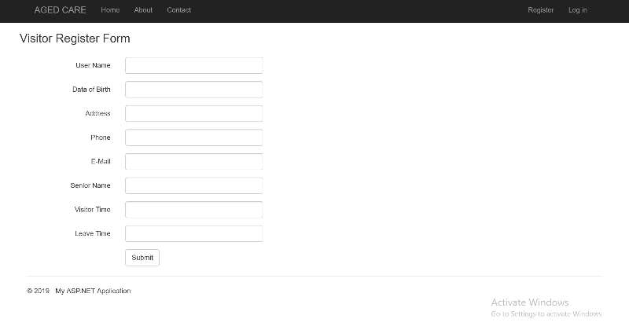

**1.5.4 As an administrator I want to Log in**

**1. User Story Definition**

**As an** Administrator **I want to** log-on to the website **so that** I can use the website function to add or update my details.

I can add and update my details such as :

* my profile (personal details)
* details that related to my patient

|  |  |
| --- | --- |
| **Story Points** | **Acceptance criteria** |
| Story Points: 3 | 1. Username/password combination are accepted when they are registered in the database. Dashboard page is displayed where other functions can be accessed. 2. Username / password combination are rejected with an error message when they are not registered in the database. |

**2. Flow of Interaction**

N/A

**3. User Story Testing**

|  |  |  |  |
| --- | --- | --- | --- |
| **Test ID** | **Test Objective** | **Expected Output** | **Status (Pass/Fail)** |
| 4.3.3.1 | Test that a valid username/password combination allows a user to sign into the Aged Care Website. | Successfully sign into the website and access other functions from the Aged Care website homepage. |  |
| 4.3.3.2 | Test that an invalid username/password combination does not allow a user to sign into the Aged Care Website. | Error message |  |

**4. Integration Testing**

N/A

**5. Wire frame**

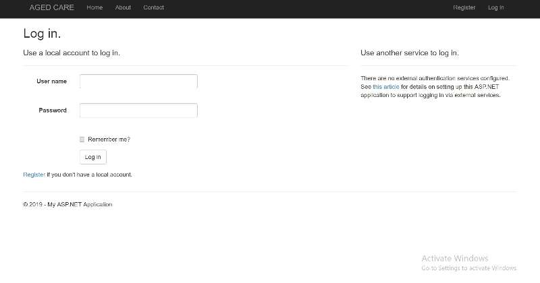

**1.5.5 As an Administrator I want to Log out**

**1. User Story Definition**

**As an** administrator **I want to** sign-out of the website for security reasons **so that** my personal account is protected.

|  |  |
| --- | --- |
| **Story Points** | **Acceptance criteria** |
| Story Points: 1 | 1. User is logged out of the website, anyone else using the same computer as the user who has logged out of the application will need to log into the Aged Cared Website to use it. |

**2. Flow of Interaction**

N/A

**3. User Story Testing**

|  |  |  |  |
| --- | --- | --- | --- |
| **Test ID** | **Test Objective** | **Expected Output** | **Status (Pass/Fail)** |
| 4.4.3.1 | Test that Log out button allows user to sign out of the website. | Successfully sign-out of the website |  |

**4. Integration Testing**

N/A

**5. Wire frame**

Close the Website

**1.5.6 As an Administrator I want to retrieve password when I do not remember login details**

**1. User Story Definition**

**As an** administrator **I want to** retrieve my password when I forget my login details **so that** I can log-in again.

After I login I can add and update my details such as :

* my profile (personal details)

|  |  |
| --- | --- |
| **Story Points** | **Acceptance criteria** |
| Story Points: 4 | 1. When user clicks the link that to retrieve their username and password back if they forget them. The proper message will then send to their email. |

**2. Flow of Interaction**

N/A

**3. User Story Testing**

|  |  |  |  |
| --- | --- | --- | --- |
| **Test ID** | **Test Objective** | **Expected Output** | **Status (Pass/Fail)** |
| 4.5.3.1 | Test that the retrieve details link is successful when it is clicked. | Successfully send proper message to the user. |  |

**4. Integration Testing**

N/A

**5. Wire frame**

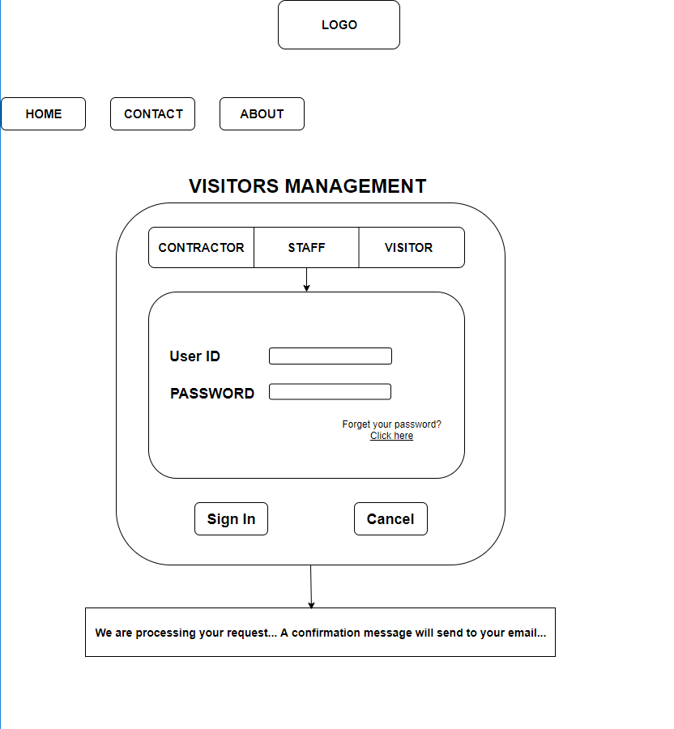

**1.5.7 As an Administrator I want to book visiting time on the website**

**1. User Story Definition**

**As** an Administrator **I want to** book visiting time on the website **so that** I can visit my patient.

After I login I can provide booking time details such as:

* Expected Visiting Time
* Details that related to my patient

|  |  |
| --- | --- |
| **Story Points** | **Acceptance criteria** |
| Story Points: 5 | * User needs to be registered and signed in. * User needs to select visiting types(Individual or Group) * User needs to provide visiting details and expected visiting time |

**2. Flow of Interaction**

N/A

**3. User Story Testing**

|  |  |  |  |
| --- | --- | --- | --- |
| **Test ID** | **Test Objective** | **Expected Output** | **Status(Pass/Fail)** |
| 4.6.3.1 | To test that a booking request can be submitted | Accept a request |  |
| 4.6.3.2 | To test that a booking request that has no details can not be submitted | Do not accept an empty request. Return a message to fill the details |  |

**4. Integration Testing**

N/A

**5. Wireframe**

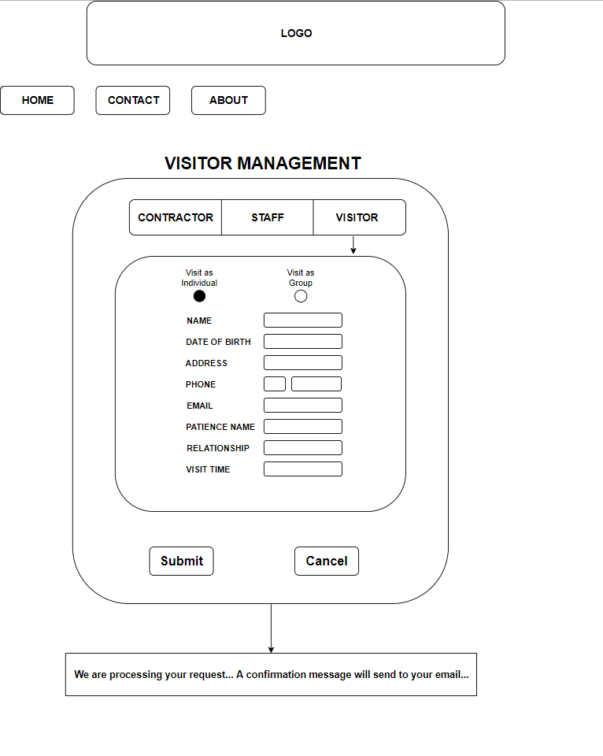

**1.5.8 As an Administrator I want to cancel the booking time on the website**

**1. User Story Definition**

**As** an Administrator **I want** to cancel the booking time on the website **so that** I can change my schedule.

After I login I can cancel my booking time request

|  |  |
| --- | --- |
| **Story Points** | **Acceptance criteria** |
| Story Points: 2 | * User needs to be registered and signed in. * User cancel the booking time by clicking the cancel button |

**2. Flow of Interaction**

N/A

**3. User Story Testing**

|  |  |  |  |
| --- | --- | --- | --- |
| **Test ID** | **Test Objective** | **Expected Output** | **Status(Pass/Fail)** |
| 4.7.3.1 | To test that a booking request can be cancelled | Cancel a request |  |

**4. Integration Testing**

N/A

**5. Wireframe**



**1.5.9 As a Website Provider I want to register**

**1. User Story Definition**

**As a** Website Provider **I want to** register on website **so that** I can log in to the website.

After I login I can add my details such as:

* my profile (personal details)
* details that about the website that I can provide to the administrators

|  |  |
| --- | --- |
| **Story Points** | **Acceptance criteria** |
| Story Points: 3 | Valid data is accepted and invalid data is rejected as follows :-   1. Valid username and password combination will be accepted and registered in the database. 2. Username not unique – rejected 3. Username is null – rejected 4. Password is null – rejected |

**2. Flow of Interaction**

N/A

**3. User Story Testing**

|  |  |  |  |
| --- | --- | --- | --- |
| **Test ID** | **Test Objective** | **Expected Output** | **Status(Pass/Fail)** |
| 4.8.3.1 | Test that a valid details allow a website provider to access the Aged care website. | Successfully registered as a website provider who is then able to login to the Aged Care website |  |
| 4.8.3.2 | Test that a username which is already in use can not be used to register | Error message |  |
| 4.8.3.3 | Test that a username can not be null | Error message |  |
| 4.8.3.4 | Test that a password can not be null | Error message |  |

**4. Integration Testing**

N/A

**5. Wire frame**

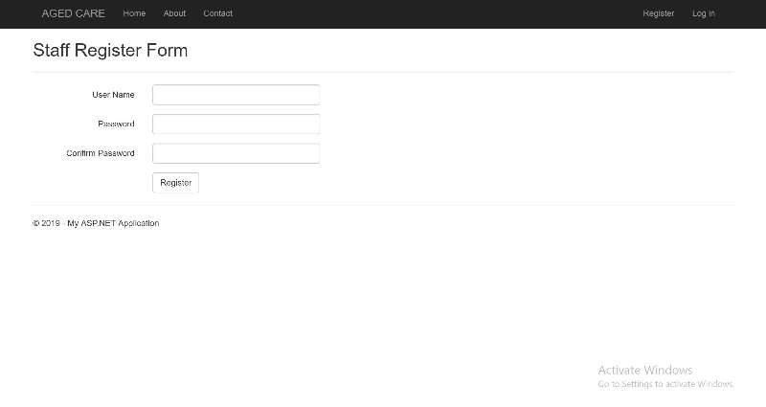

**1.5.10 As a Website Provider I want to Log in**

**1. User Story Definition**

**As a** Website Provider **I want to** log-on to website **so that** I can use the website function to add or update my details.

I can add and update my details such as :

* my profile (personal details)
* details about the website that i provider to the administrators

|  |  |
| --- | --- |
| **Story Points** | **Acceptance criteria** |
| Story Points: 3 | 1. Username/password combination are accepted when they are registered in the database. Dashboard page is displayed where other functions can be accessed. 2. Username / password combination are rejected with an error message when they are not registered in the database. |

**2. Flow of Interaction**

N/A

**3. User Story Testing**

|  |  |  |  |
| --- | --- | --- | --- |
| **Test ID** | **Test Objective** | **Expected Output** | **Status (Pass/Fail)** |
| 4.9.3.1 | Test that a valid username/password combination allows a user to sign into the Aged Care Website. | Successfully sign into the website and access other functions from the Aged Care website homepage. |  |
| 4.9.3.2 | Test that an invalid username/password combination does not allow a user to sign into the Aged Care Website. | Error message |  |

**4. Integration Testing**

N/A

**5. Wire frame**

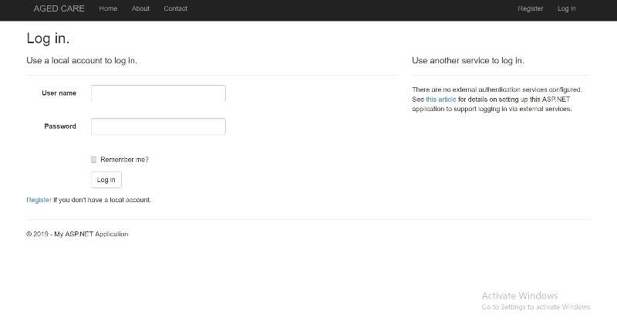

**1.5.11 As a Website Provider I want to Log out**

**1. User Story Definition**

**As a** Website Provider **I want to** sign-out of the website for security reasons **so that** my personal account is protected.

|  |  |
| --- | --- |
| **Story Points** | **Acceptance criteria** |
| Story Points: 1 | 1. User is logged out of the website, anyone else using the same computer as the user who has logged out of the application will need to log into the Aged Cared Website to use it. |

**2. Flow of Interaction**

N/A

**3. User Story Testing**

|  |  |  |  |
| --- | --- | --- | --- |
| **Test ID** | **Test Objective** | **Expected Output** | **Status (Pass/Fail)** |
| 4.10.3.1 | Test that Log out button allows user to sign out of the website. | Successfully sign-out of the website |  |

**4. Integration Testing**

N/A

**5. Wire frame**

Close the Website

**1.5.12 As a Website Provider I want to retrieve password when I do not remember login details**

**1. User Story Definition**

**As a** Website Provider **I want to** retrieve my password when I forget my login details **so that** I can log-in again.

After I login I can add and update my details such as :

* my profile (personal details)

|  |  |
| --- | --- |
| **Story Points** | **Acceptance criteria** |
| Story Points: 4 | 1. When user clicks the link that to retrieve their username and password back if they forget them. The proper message will then send to their email. |

**2. Flow of Interaction**

N/A

**3. User Story Testing**

|  |  |  |  |
| --- | --- | --- | --- |
| **Test ID** | **Test Objective** | **Expected Output** | **Status (Pass/Fail)** |
| 4.11.3.1 | Test that the retrieve details link is successful when it is clicked. | Successfully send proper message to the user. |  |

**4. Integration Testing**

N/A

**5. Wire frame**



**1.5.13 As a Website Provider I want to know the booking details when it is a group booking request**

**1. User Story Definition**

**As** a Website Provider **I want** to know the booking details when it is a group booking request **so that** I can.

After I login I can cancel my booking time request

|  |  |
| --- | --- |
| **Story Points** | **Acceptance criteria** |
| Story Points: 4 | * User needs to be registered and signed in. * User then can have the view of the request details. |

**2. Flow of Interaction**

N/A

**3. User Story Testing**

|  |  |  |  |
| --- | --- | --- | --- |
| **Test ID** | **Test Objective** | **Expected Output** | **Status(Pass/Fail)** |
| 4.12.3.1 | To test that a group booking request can be viewed | Display the booking request details |  |

**4. Integration Testing**

N/A

**5. Wireframe**

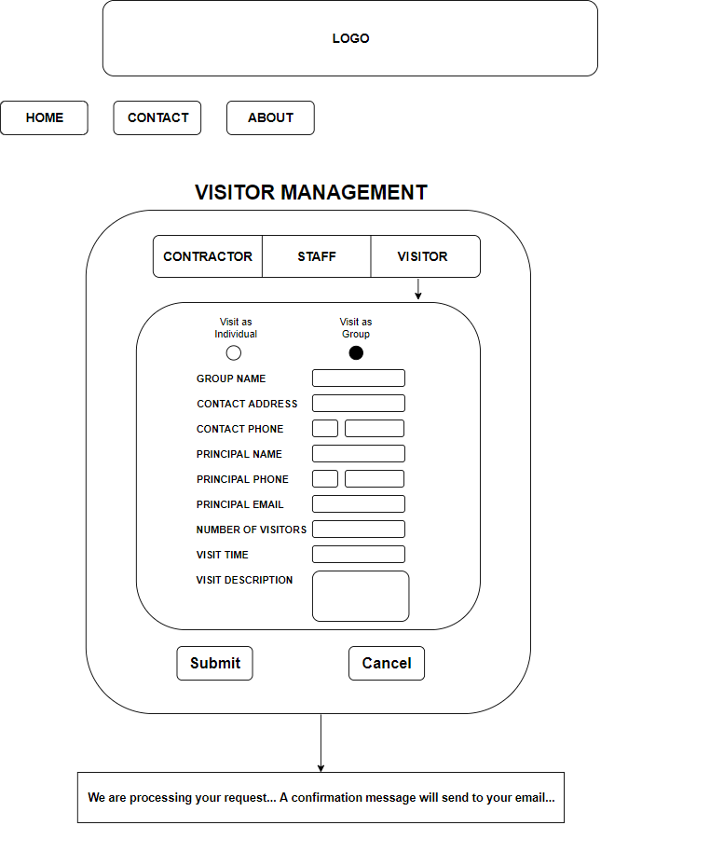

**1.6 5.0 Object-Oriented Design**

**1.6.1 High Level System Architecture**

The section provides an overview of the entire visitor management system segment into sub-systems for easier understanding

A high-level architecture diagram depicts following:

* components, interfaces, platforms, services and networks
* work flows and/or data flows between components
* brief consideration of all significant commercial, legal, environmental, security, safety and technical risks, issues and assumptions

clearly understand of the visitor management system overview is important. It is crucial to introduce how the system is laid out, and generally how the implementations will be handled.

**High Level System Architecture**

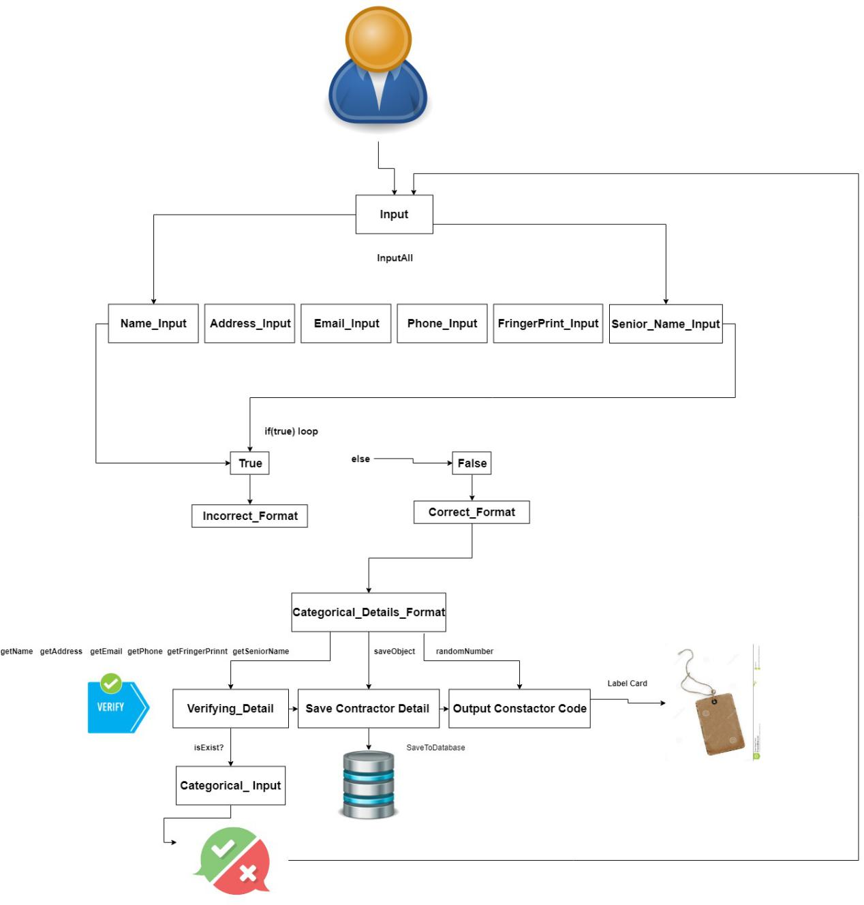

This system is designed for contractor sign in occasion. Firstly, input details of contractor for registration or log in. Then, the system valid detail and output label card for verification purpose.

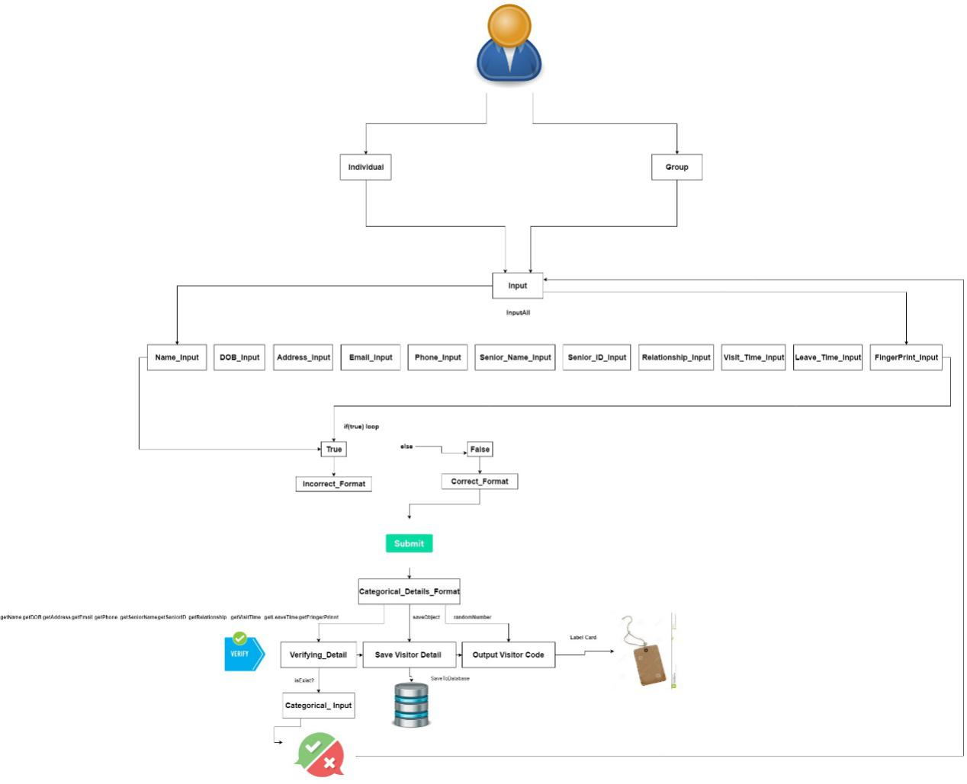

This part designed for visitor sign in occasion. Firstly, input details of visitor for registration or log in. Then, the system valid detail and output label card for verification purpose. Additionally, the visitor can be distinguished for two different groups, individual and group.

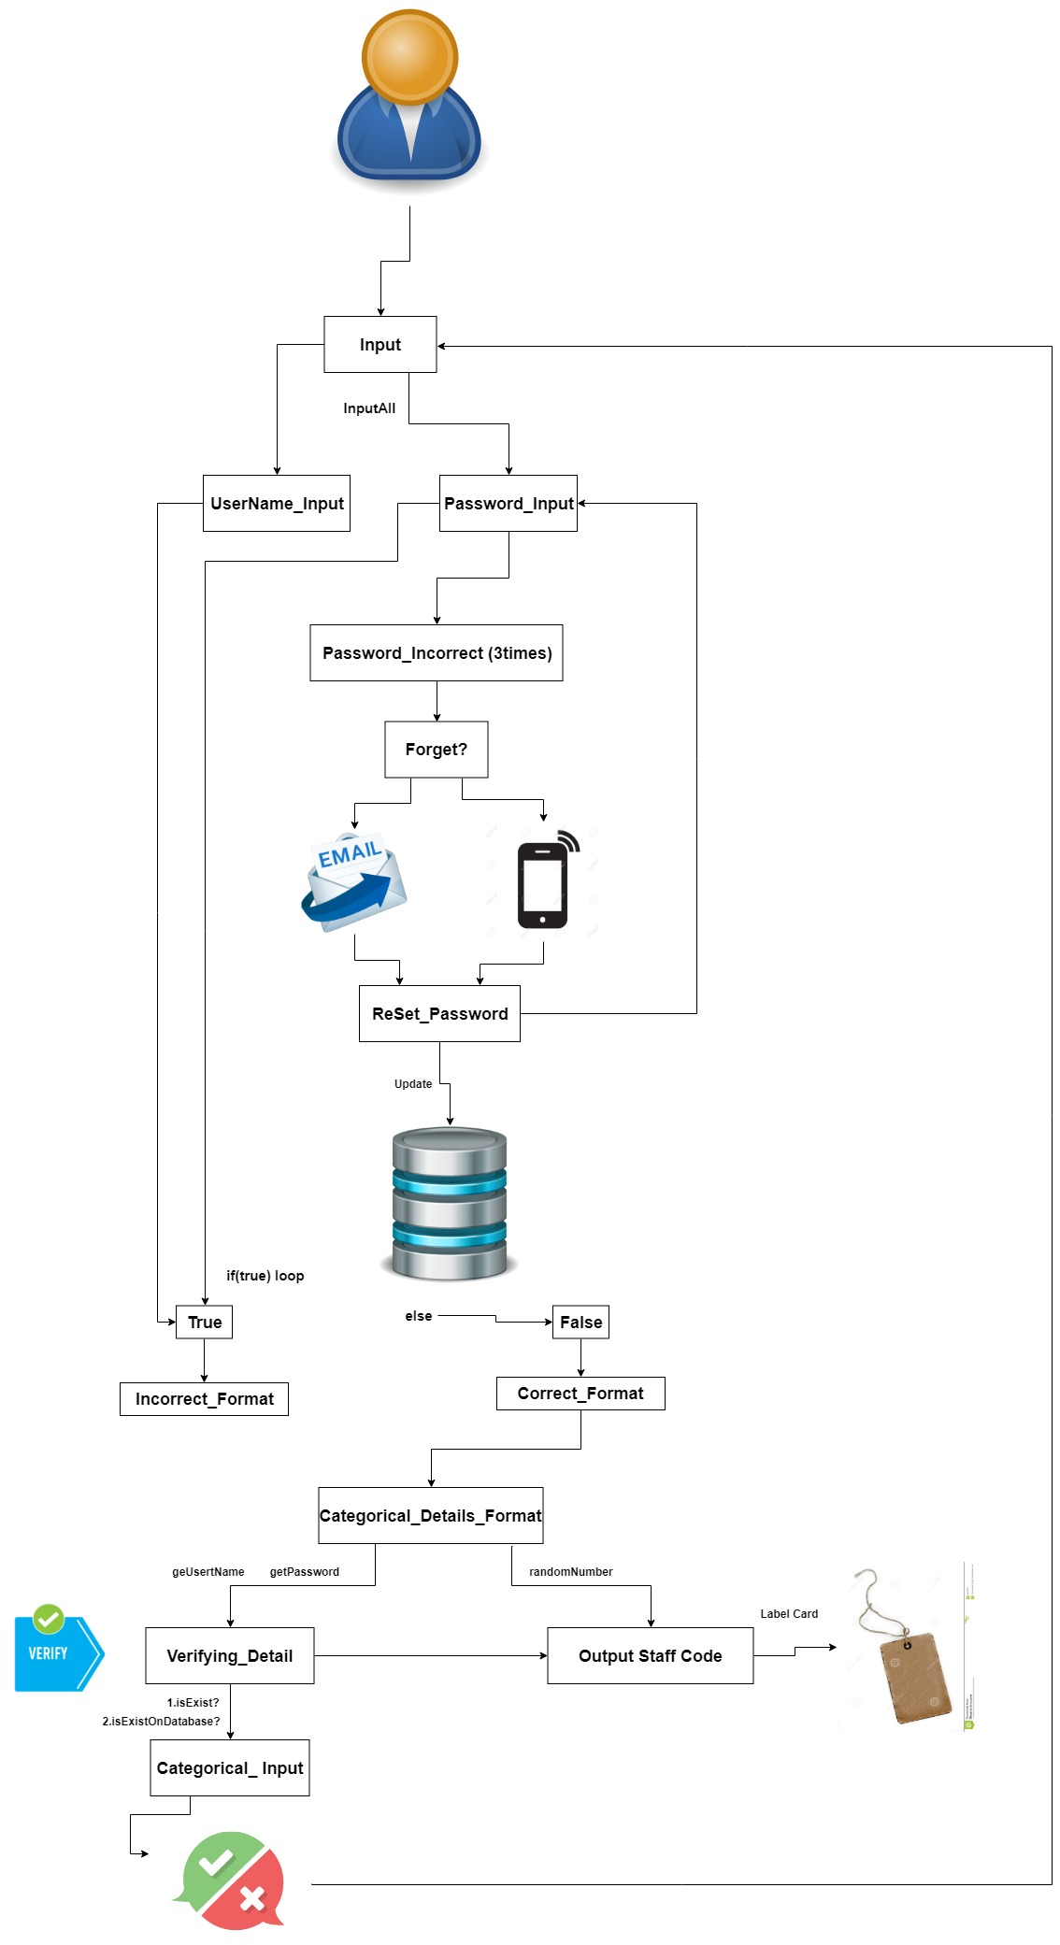

This section is designed for staff sign in occasion. Firstly, input details of staff for registration or log in. Then, the system valid detail and output label card for verification purpose. Additionally, a password retrieval system is designed via validating e-mail or phone text.

**1.6.2 Use Case Diagram**

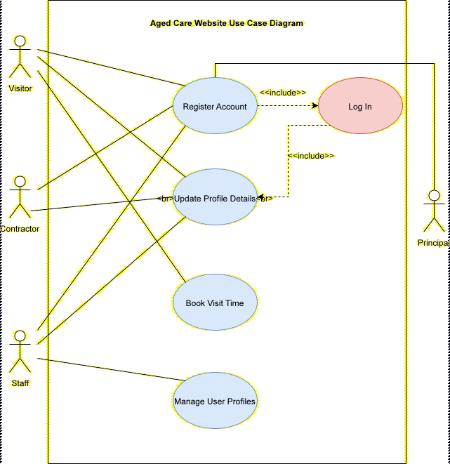

**1.6.3 Modular GUI**

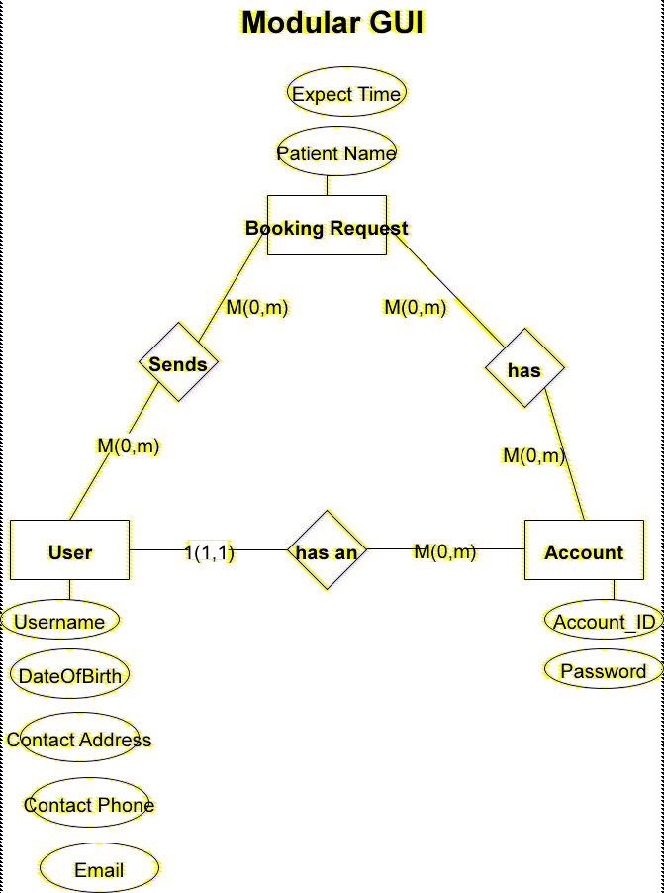

**1.6.4 Object Dictionary**

Objects

API

|  |  |  |  |  |
| --- | --- | --- | --- | --- |
| Name | Package/Service | Type | Description | Signature |
| Visitor | Visitor management | Object | Represents a Visitor, creates an instance of a visitor in memory and contains all the attributes and methods that model and handlel its information | Visitor() |
| Staff | Staff management | Object | Represents a Staff, creates an instance of a visitor in memory and contains all the attributes and methods that model and handlel its information | Staff() |
| Contractor | Contractor management | Object | Represents a Contractors, creates an instance of a visitor in memory and xcontains all the attributes and methods that model and handlel its information | Contractor() |
| Reservation | Reservation management | Object | Represents a reservation made by visitor, creates an instance of a reservation in memory and contains all the attributes and methods that model and handlel its information | Reservation() |
| Registration | Registration management | Object | Represents a Visitor, creates an instance of a visitor registration in memory and contains all the attributes and methods that model and handlel its information | Registration() |

Object Attributes

Visitor

|  |  |  |  |  |  |
| --- | --- | --- | --- | --- | --- |
| Name | Object | Package/Service | Type | Description | Signature |
| ID | Visitor | Visitor management | Attribute | Contains the user ID as an integer of the user in memory | $id |
| Name | Visitor | Visitor management | Attribute | Contain the name of the visitor as a string in memory | $name |
| Username | Visitor | Visitor management | Attribute | Contain the username of the visitor as a string in memory | $username |
| Password | Visitor | Visitor management | Attribute | Contain the password of the visitor as a string in memory | $password |
| Address | Visitor | Visitor management | Attribute | Contain the address of the visitor as a string in memory | $address |
| Phone | Visitor | Visitor management | Attribute | Contain the phone number of the visitor as a string in memory | $phone |
| Email | Visitor | Visitor management | Attribute | Contain the email of the visitor as a string in memory | $email |
| Senior Name | Visitor | Visitor management | Attribute | Contain the visiting name of the visitor as a string in memory | $senior_name |
| Visit Time | Visitor | Visitor management | Attribute | Contain the visiting time of the visitor as a string in memory | $visiting_time |
| Leave time | Visitor | Visitor management | Attribute | Contain the leave time of the visitor as a string in memory | $leave_time |

Staff

|  |  |  |  |  |  |
| --- | --- | --- | --- | --- | --- |
| Name | Object | Packge/Service | Type | Description | Signature |
| username | Staff | Staff management | Attribute | Contain the username of the staff as a string in memory | $staff_username |
| password | Staff | Staff management | Attribute | Contain the password of the staff as a string in memory | $staff_password |
|  |  |  |  |  |  |
|  |  |  |  |  |  |

Contractor

|  |  |  |  |  |  |
| --- | --- | --- | --- | --- | --- |
| Name | Object | Package/service | Type | Description | Signature |
| Username | Contractor | Contractor  Management | Attribute | Contain the username of the contractor as a string in memory | $ Contractor_username |
| Password | Contractor | Contractor  Management | Attribute | Contain the password of the contractor as a string in memory | $ Contractor_password |
| Phone | Contractor | Contractor  Management | Attribute | Contain the phone of the contractor as a string in memory | $ Contractor_phone |
| Email | Contractor | Contractor  Management | Attribute | Contain the email of the contractor as a string in memory | $ Contractor_email |
| Senior name | Contractor | Contractor  Management | Attribute | Contain the senior name of the contractor as a string in memory | $ Contractor_seniorName |

Methods/Functions

Visitor

|  |  |  |  |  |  |  |
| --- | --- | --- | --- | --- | --- | --- |
| Name | Object | Package/service | Type | Description | Signature | Parameters(input) |
| SignupAction() | Visitor | Visitor Management | Post | Registers visitor in database and provides a session token to login or logout | signupAction() | *@apiparam  {String} username Mandatory username of the visitor  *@apiparam  {String} password Mandatory password of the visitor  *@apiparam  {String} name Mandatory name of the visitor |
| LoginAction() | Visitor | Visitor Management | Post | Log in the visitor privides a session token to login or logout | LoginAction() | *@apiparam  {String} username Mandatory username of the visitor  *@apiparam  {String} password Mandatory password of the visitor |
| GetReservationAction() | Visitor | Visitor Management | Post | Get the reservation for the visitor indentifying the token of the session | GetReservationAction() | {String} reservationTime Mandatory reservation time of the visitor  *@apiparam  {String} LeaveTime Mandatory leave time of the visitor  {String} seniorNameMandatory visiting seniorName of the visitor |
| AddReservationAction() | Visitor |  | Post | Add a reservation to visitor’s request | AddReservationAction() | {String} reservationTime Mandatory reservation time of the visitor  *@apiparam  {String} LeaveTime Mandatory leave time of the visitor  {String} seniorNameMandatory visiting seniorName of the visitor |

**6.0 Software Release Report**

(To be combined in Industry Project 3B)

**7.0 Additional User Interface Design**

(To be combined in Industry Project 3B)

**8.0 Special Notes**

**Glossary of Terms**

**A**

**API** is a pre-defined function that provide the ability for applications and developers to access a set of routines based on a piece of software or hardware without having to access source code or understand internals

**C**

**CSS** is a computer language used to represent file styles such as HTML or XML. CSS can not only statically modify web pa ges but also dynamically format various elements of web pages with various scripting languages

**D**

**Database** can be regarded as an electronic file cabinet the location where the electronic file is stored. User can add, intercept, update, delete, etc. the data in the file

**H**

**HTML** stands for HyperText Mark-up Language is a basic technology often used by CSS and JavaScript to design the web pages, web applications and mobile application user interfaces

**M**

**MySQL** is an open-source relational database management system

**P**

**PHP** is an open-source, general-purpose computer scripting language that is especially useful for web development and can be embedded in HTML

**S**

**Server** is a computer software that manages the resources and provides services to users, usually divided into file servers, database servers and application servers.

**T**

**Testing** is a process used to facilitate the authenticity, integrity, security and quality of an authentication software

**U**

**User Story** is a common term used in software development and project management. It helps the designer to write valuable functions, guidance and frameworks to interact with users in the perspective of customers or users, thereby driving the work process. Can be considered a specification file but more precisely. It represents the customer’s needs and direction.

**W**

**Web** is an Internet based on a system of Internet servers that support by specially formatted documents. It also supports other types of files such as videos files, audio and graphics

**Statement of effort**

**Statement of Authorship**

* **Unit Code CSE3PRA**
* **Unit Name INDUSTRY PROJECT A**
* **Lecturer/Tutor’s Name: Mrs Elle Chan**
* **Coordinator: Dr Torab Torabi**
* **Assignment No.1**
* **Name of Document System Maintenance Document**

|  |  |
| --- | --- |
| **Family Name**( Block Letters) | **LI** |
| **Given Name** | **Xiaopeng** |
| **Student No** | **18386537** |
| **Signature** | **Xiaopeng Li** |
| **Family Name**( Block Letters) | **Xie** |
| **Given Name** | **Ruolin** |
| **Student No** | **18827929** |
| **Signature** | **Ruolin Xie** |
| **Family Name**( Block Letters) | **Tai** |
| **Given Name** | **Yone Min** |
| **Student No** | **19190983** |
| **Signature** | **Tai Yone Min** |
| **Family Name**( Block Letters) | **Yin** |
| **Given Name** | **Yue** |
| **Student No** | **19180306** |
| **Signature** | **Yue Yin** |